How To Assign a Contact to a Listing
1. Login to your ProAgent Solutions Account
2. Select "Your Listings" from the drop-down menu under "Listings"
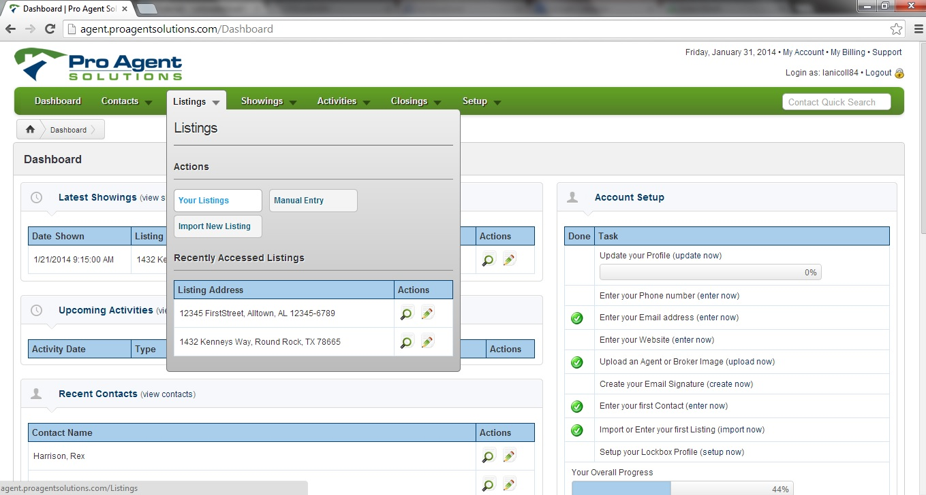
3. Select the Pencil Icon to the right of the listing you wish to edit
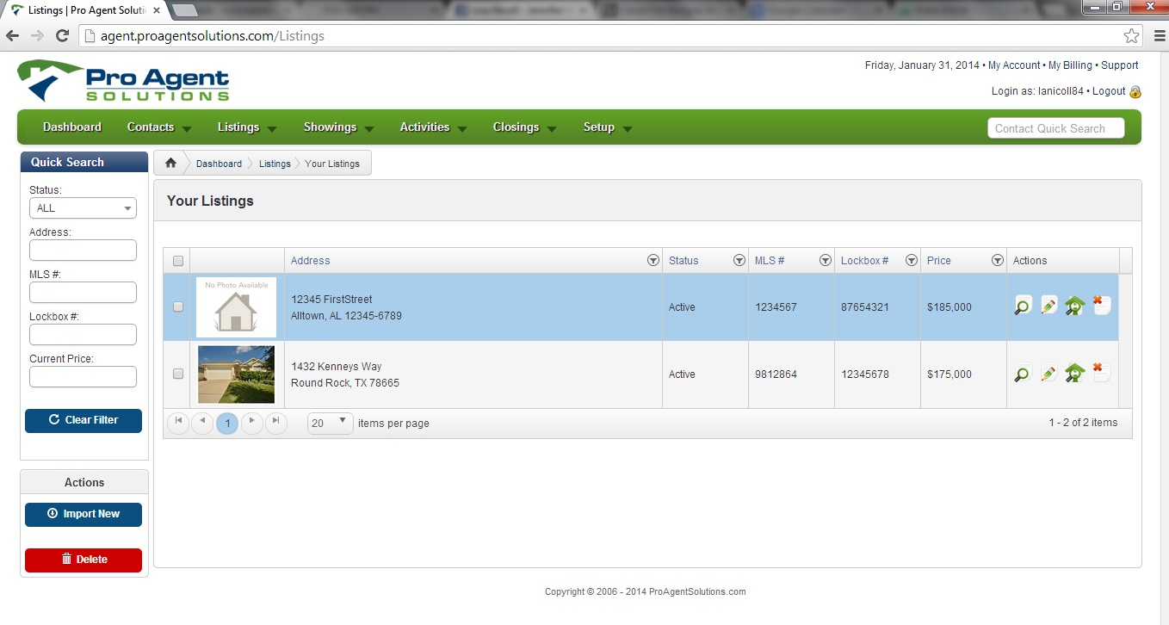
4. Move cursor to Property Contact box, and select Contact from drop-down list 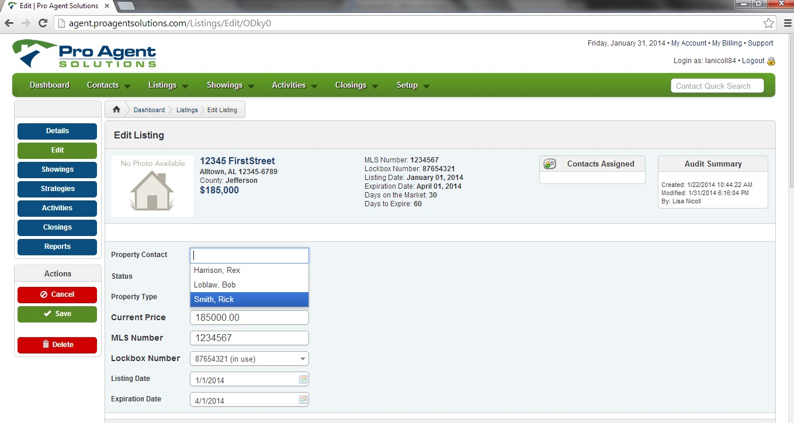
5. Click "Save" to save any changes to the listing. 